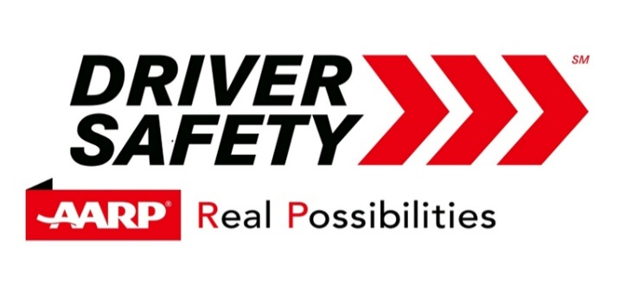

AARP Smart Driving for Older Adults will be offered in the Anne Arundel County Office of Partners In Care Maryland, Inc., 8151-C Ritchie Highway, Pasadena, from 9:00 am to 1:00 pm on the following dates:

- 24 March 2020
- 09 June 2020
- 15 September 2020
- 15 December 2020

The class is FREE to PIC members. It is also open to the public at a cost of $15 for AARP members and $20 for non-AARP. Starting in September 2020, the price will be increased to $20 for AARP members and $25 for non-AARP members.

Space is limited and reservations are required. Sign up at the front desk of the Partners In Care office or call 410-544-4800.

