FY18-19 ANNUAL REPORT
PARTNERS IN CARE, MARYLAND, Inc.

August 19, 2019

OVERVIEW
In its 26th year, Partners In Care Maryland continues to be the pre-eminent source of private, volunteer services for seniors, age 50 and over, who choose to remain independent as they age in place. The cornerstone of PIC’s volunteer services is its Ride Partners program, a program that delivers scheduled transportation assistance to seniors, using volunteer drivers and/or mobility bus service. Volunteers use their own cars to deliver arm-in-arm, door-through-door transportation at no cost to the riders for medical appointments, grocery shopping, errands, and numerous other activities that enable seniors to remain active, healthy and engaged in their communities. Mobility bus services are provided to those whose mobility is more restricted. Members can take advantage of PIC’s transport services at no cost, and they are also engaged to participate in other facets of the program --- “Handyman/Handywomen”, “Member Care” and “Program Helpers”. Below, we profile activity in all areas during FY19.

PIC “RIDE PARTNER” AND MOBILITY BUS SERVICES
PIC’s transportation program continued to grow in the fiscal year ended 6/30/19. By contrast with the prior fiscal year, all of the core metrics PIC monitors to manage the program, increased substantially over FY18. Total trips increased by 4.3%, total volunteer hours by 10.9%, total miles driven by 16.1%, and total riders by 15.6%! The only exception to this was the total number of volunteer drivers, which fell by 8.9%. However, this simply means that a slightly smaller group of volunteers, 31 fewer to be precise (e.g. 346 vs. 315), accounted for all the increases reported above. When viewed from this perspective, the accomplishments noted above are even more impressive, and indicate PIC volunteers “stepped up”, to fill a growing demand for assistance!

PIC not only demonstrated an ability to deliver more rides, but it also converted more requests into actual rides. This was true across all three county sites – Anne Arundel. Frederick and Upper Shore (Caroline and Talbot counties). The chart on the following page displays the percentage of total requests fulfilled by each site. Across all sites, between FY18 and FY19, this percent rose from 86% to 89%.

As readers know, PIC delivers transport assistance across Maryland in three locations covering four counties– Frederick (Frederick county), Pasadena (Anne Arundel county) and in Easton on the upper Eastern Shore (Caroline and Talbot county). An appendix to this report contains visual displays of the scope of transportation throughout each service area, and number of rides completed in each area.
PIC’s transportation service reaches all income and ethnic groups, in terms of counts of trips delivered

and the number of volunteer hours committed to each of four income groups – those with less than $900 / month, monthly incomes between $901 - $1800, $1801 and $2500, and incomes greater than $2500. To help readers understand how these groups relate to the Federal Poverty level (e.g. FPL), any member with a monthly income less than $1,041 per month, falls within the FPL limit. The “less than $900 per month”, group clearly falls into this group. However, some portion of members whose incomes are between $901-$1800, also falls in this group. Thus, the above graph suggests roughly 25-40% of trips delivered by PIC drivers were done for members whose income fell within 100-200% of FPL. As the graph below also illustrates, this proportion carried over to the percent of volunteer hours completed for trips to members in this income range as well.

The demographic make-up of PIC riders is also broadly representative of all major race and ethnic groups in PIC’s three locations. Seventy-five (75.3%) percent of all rides are delivered to white seniors, 18% (17.99%) to African American seniors, 2.5% to Hispanic members, and the remaining are distributed across Native American, Asian and Middle-Eastern members. The age distribution of members who receive transport assistance (or accompany members) is displayed on the following page.
NON-TRANSPORTATION SERVICES
PIC is reputed to deliver not “just rides, but relationships” --- lifelong relationships at that. There are many opportunities for members to contribute their time, talents and skills, to assist their senior neighbors. When seniors become members, they are screened, interviewed and engaged to contribute in a variety of ways. Members can be volunteers in certain areas, and consumers in others, but all are engaged to participate in some area of the program.
The chart on the following page displays the number of tasks and hours of contributed time by members to one of PIC’s non-transportation programs.

PIC’s transportation program is clearly the cornerstone of its overall enterprise. Total trips in FY19 were 9750. But the non-transportation components are also substantial. and usually are the ones that members can participate in, or take advantage of, once they become more familiar with the numerous ways each can contribute to, or avail themselves of, once they become part of the enterprise. These “other” program areas are typically ones around which “relationships” are formed throughout the program. The “Total Trips & Tasks” exhibit below shows that PIC members completed 7588 tasks in

FY19. For these 7588 tasks, members volunteered 18,240 hours of their time. These hours represented 62% of the total program hours in FY19, or 29,326 hours. To understand how “relationships” are formed within PIC, one need only understand that non-transportation tasks account for just 43% of total tasks completed, but they account for nearly two-thirds of total hours volunteered. Thus, when members contribute to either Handyman, Member Care, or Program Help, these tasks average more than 2.5 hours per task. By contrast, rides delivered by volunteers typically average slightly more than one hour. Only certain members can be volunteer drivers, but all can contribute their time and talents so many other ways, to help their neighbors.
THE FUTURE – FY20
Looking forward to FY20, PIC anticipates growth in the numbers of seniors served, but more importantly, in the depth and scope of relationships formed among its more than 3000 active members, and local stakeholders across Maryland, who share a commitment to helping seniors age in place.
Highlights of key initiatives either planned or already underway for FY20 are:
- Expansion of PIC’s Executive Board and advisory board members in all service areas
- Key full time staff in all three locations, including a new chief of operations, marketing director, new site directors and site coordinators
- New mobility van services in Frederick
- New office location in Easton, Maryland
- New relationships with hospitals and human service organizations in all three areas, to focus with laser precision on improving the social determinants of health among the older adult community
- Addition of an expanded jewelry retail service in the central Boutique store in Pasadena, and
- Expansion of streamlined, web-based, volunteer to volunteer, ride matching systems in all three service locations
Finally, one example of the anticipation that PIC holds for FY20, may best be captured by a new member, Greg, one of our new “Handymen/Handywomen” members. His volunteer spirit is truly extraordinary. Greg is 52. He does carpentry, masonry, painting, plumbing, and computer repairs. Oh, by the way, Greg is also wheel-chair limited. Yet, he drives himself to all job sites! Greg doesn’t ask for service, he delivers it! He also isn’t just a “handyman”, he mends hearts and spirits, by his mere presence! There is NO cost for his efforts, but priceless, in its value and return, to himself and all PIC members whose life he touches!
Greg’s story is inspirational to say the least. But countless other stories also come from PIC’s other volunteers -- drivers, member advocates, and program helpers! All have unique skills, talents and energy to contribute over a lifetime, and like “rides”, reach destinations and goals unimaginable when they begin.

COUNTS OF COMPLETED RIDES FOR FREDERICK PIC MEMBERS, BY LOCATION, FY19
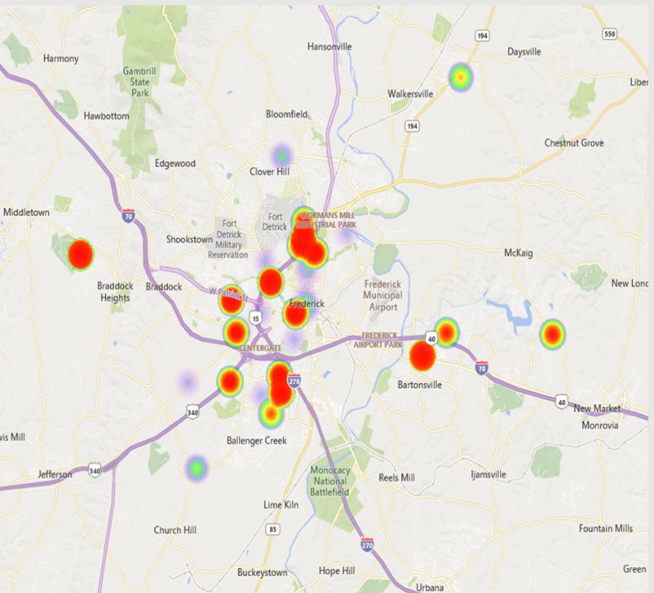 | 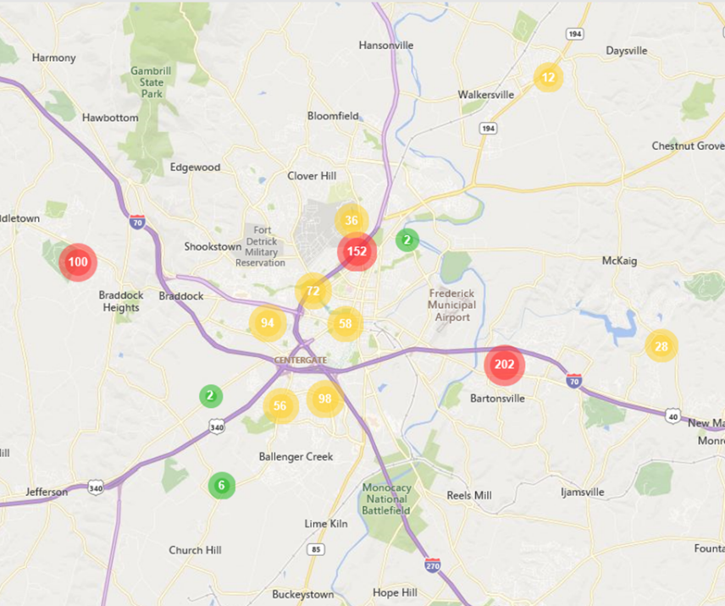

COUNTS OF COMPLETED RIDES FOR AACO PIC MEMBERS, BY LOCATION, FY19
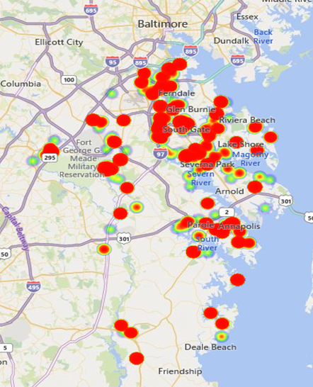 | 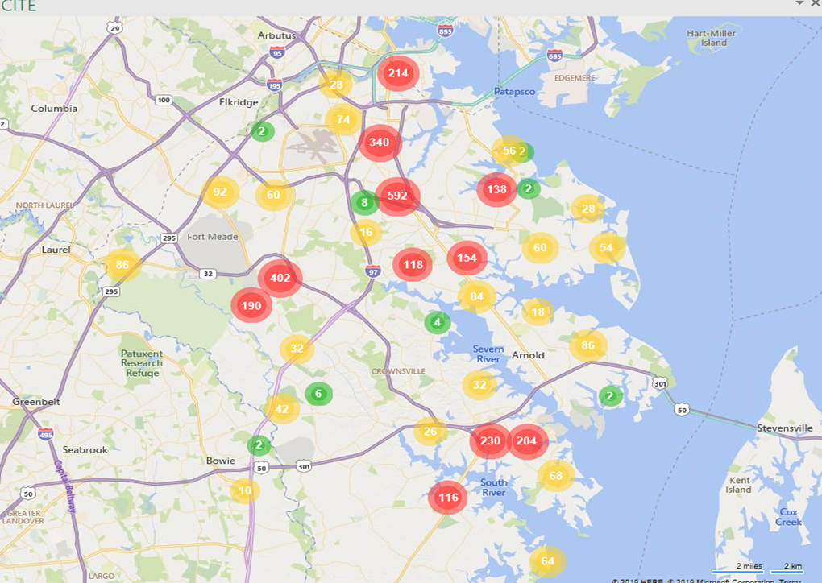

COUNTS OF COMPLETED RIDES FOR UPPER SHORE PIC MEMBERS, BY LOCATION, FY19
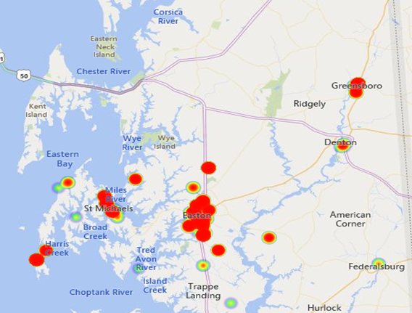

Roughly one-third of PIC members choose not to report their monthly income.

